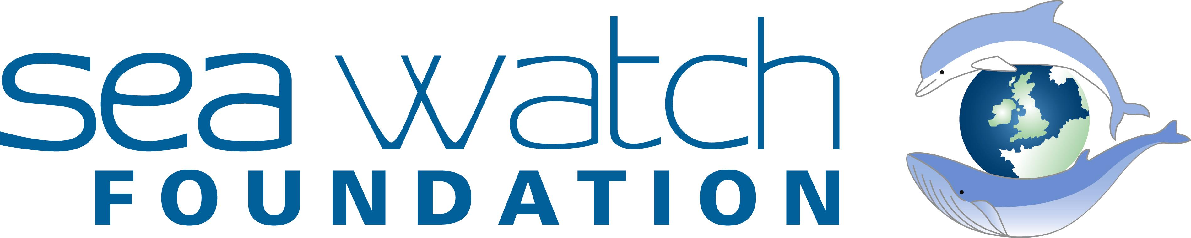
Working with the public, Sea Watch is dedicated to the conservation and protection of whales, dolphins and porpoises around the UK.

Personal details
Name of student |  | Name of guardian
Date of Birth |  | Relation to student
Contact email |  | Contact email
Contact number |  | Contact number
Preferred contact for correspondence:

Details of school
Name of school |  | Name of school contact
Address |  | Contact email
 |  | Contact number

Details of work placement
Duration of placement
What research period is the student hoping to join?
Is the student expected to complete a report or project for the work experience, if so please give details.
Will the Sea Watch Foundation be expected to complete an assessment or report for the work experience? If so please give details.

Personal statement
In no more than 500 words, briefly describe why you are applying for work experience with us and what makes you a good candidate. You can highlight any previous experience, relevant hobbies and future plans that may relate to this experience.

Medical conditions
Mention any medical or physical conditions you have so we can advise you on any precautions you may need to take during fieldwork.

